**ADBMS Experiment 7**

**Date of Performance:** 17th November 2022

**Date of Submission:** 17th November 2022

**Name:** Rosita D’mello

**SAP ID:** 60004200137

**Batch:** B3

**Branch:** Computer Engineering

**Aim:** Query Execution on an XML database

**Theory:**

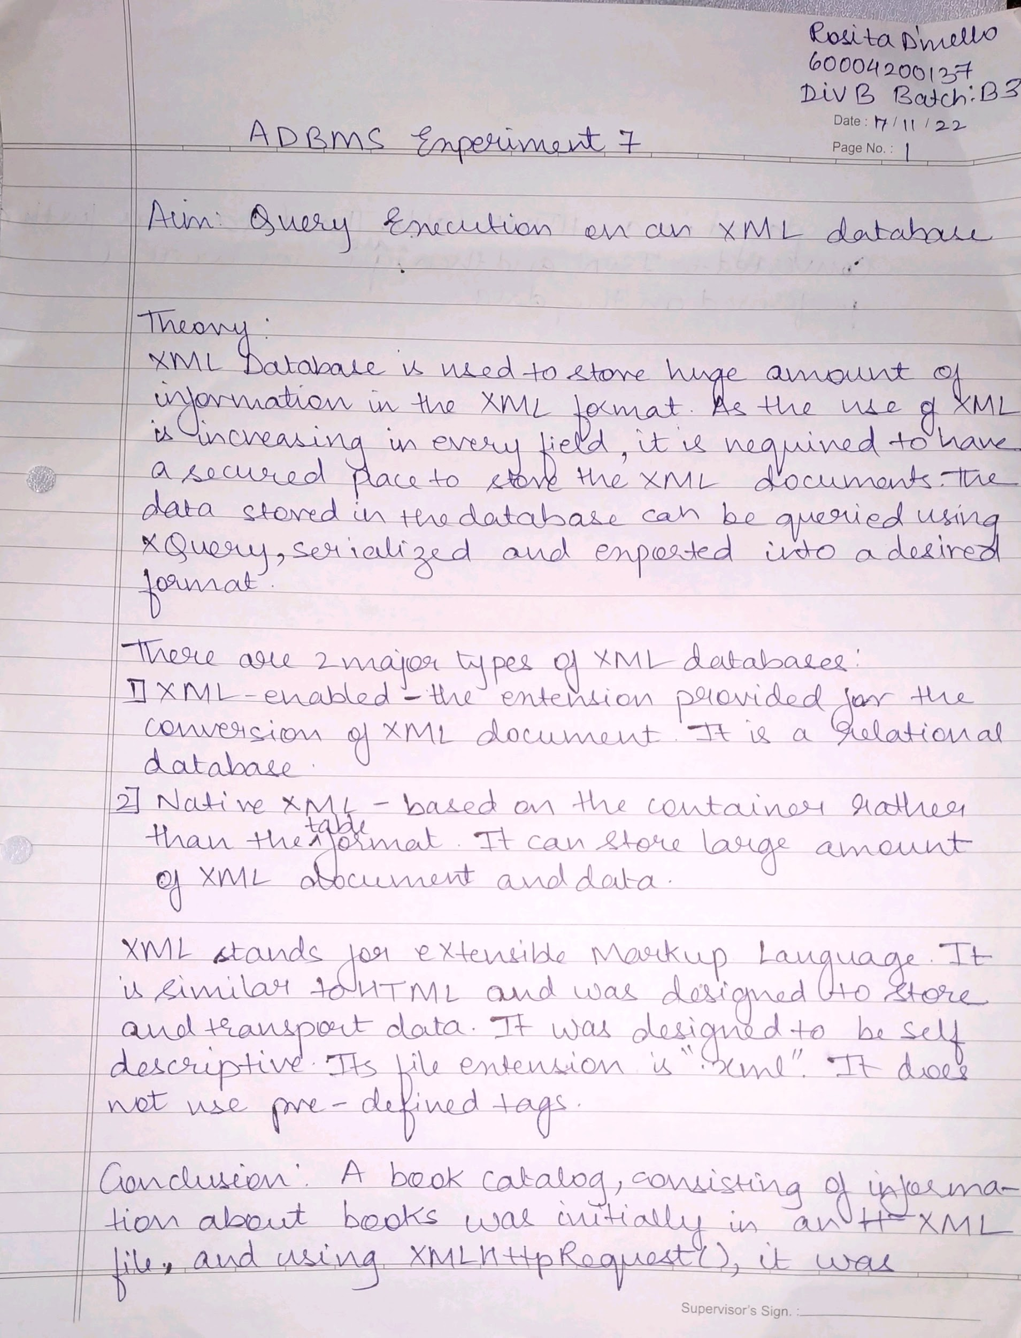

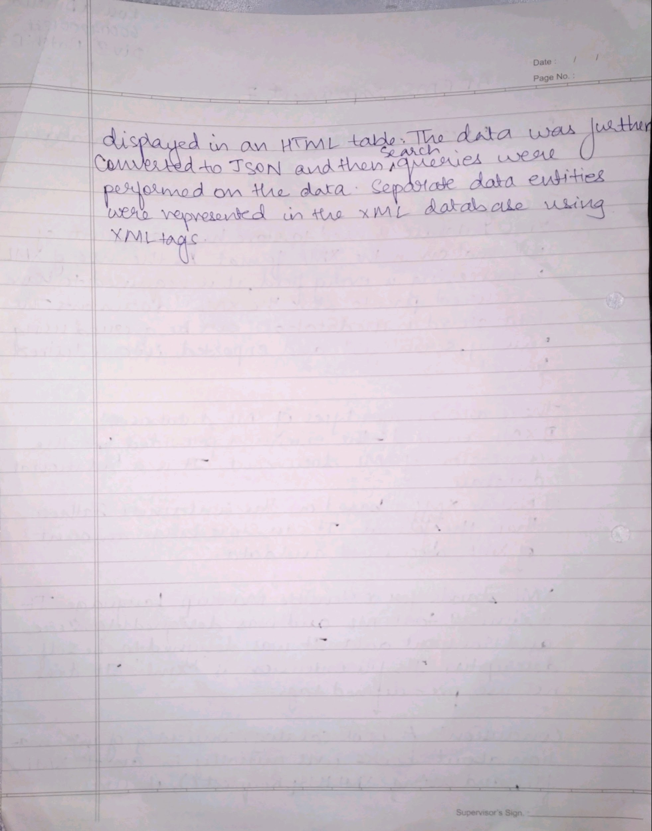

**Code:**

<html>

<head>

<style>

table, th, td {

border: 1px solid black;

border-collapse:collapse;

margin: 5px;

}

th, td {

padding: 5px;

}

input {

margin-bottom: 5px;

}

</style>

</head>

<body>

<button type="button" onclick="loadXMLDoc()">View Information about the Books</button>

<br><br>

<table id="data-table"></table>

<script>

function loadXMLDoc() {

var xmlhttp = new XMLHttpRequest();

xmlhttp.onreadystatechange = function() {

if (this.readyState == 4 && this.status == 200) {

myFunction(this);

}

};

xmlhttp.open("GET", "books.xml", true);

xmlhttp.send();

}

function myFunction(xml) {

var i;

var xmlDoc = xml.responseXML;

var table="<tr><th>Title</th><th>Author</th><th>Genre</th><th>Price</th><th>Publish Date</th><th>Description</th></tr>";

var x = xmlDoc.getElementsByTagName("book");

for (i = 0; i <x.length; i++) {

table += "<tr><td>" +

x[i].getElementsByTagName("title")[0].childNodes[0].nodeValue +

"</td><td>" +

x[i].getElementsByTagName("author")[0].childNodes[0].nodeValue +

"</td><td>" +

x[i].getElementsByTagName("genre")[0].childNodes[0].nodeValue +

"</td><td>"+

x[i].getElementsByTagName("price")[0].childNodes[0].nodeValue +

"</td><td>"+

x[i].getElementsByTagName("publish_date")[0].childNodes[0].nodeValue +

"</td><td>"+

x[i].getElementsByTagName("description")[0].childNodes[0].nodeValue +

"</td></tr>";

}

document.getElementById("data-table").innerHTML = table;

}

</script>

</body>

</html>

XML used:

<?xml version="1.0"?>

<catalog>

<book id="bk101">

<author>Gambardella, Matthew</author>

<title>XML Developer's Guide</title>

<genre>Computer</genre>

<price>44.95</price>

<publish_date>2000-10-01</publish_date>

<description>An in-depth look at creating applications

with XML.</description>

</book>

<book id="bk102">

<author>Ralls, Kim</author>

<title>Midnight Rain</title>

<genre>Fantasy</genre>

<price>5.95</price>

<publish_date>2000-12-16</publish_date>

<description>A former architect battles corporate zombies,

an evil sorceress, and her own childhood to become queen

of the world.</description>

</book>

<book id="bk103">

<author>Corets, Eva</author>

<title>Maeve Ascendant</title>

<genre>Fantasy</genre>

<price>5.95</price>

<publish_date>2000-11-17</publish_date>

<description>After the collapse of a nanotechnology

society in England, the young survivors lay the

foundation for a new society.</description>

</book>

<book id="bk104">

<author>Corets, Eva</author>

<title>Oberon's Legacy</title>

<genre>Fantasy</genre>

<price>5.95</price>

<publish_date>2001-03-10</publish_date>

<description>In post-apocalypse England, the mysterious

agent known only as Oberon helps to create a new life

for the inhabitants of London. Sequel to Maeve

Ascendant.</description>

</book>

<book id="bk105">

<author>Corets, Eva</author>

<title>The Sundered Grail</title>

<genre>Fantasy</genre>

<price>5.95</price>

<publish_date>2001-09-10</publish_date>

<description>The two daughters of Maeve, half-sisters,

battle one another for control of England. Sequel to

Oberon's Legacy.</description>

</book>

<book id="bk106">

<author>Randall, Cynthia</author>

<title>Lover Birds</title>

<genre>Romance</genre>

<price>4.95</price>

<publish_date>2000-09-02</publish_date>

<description>When Carla meets Paul at an ornithology

conference, tempers fly as feathers get ruffled.</description>

</book>

<book id="bk107">

<author>Thurman, Paula</author>

<title>Splish Splash</title>

<genre>Romance</genre>

<price>4.95</price>

<publish_date>2000-11-02</publish_date>

<description>A deep sea diver finds true love twenty

thousand leagues beneath the sea.</description>

</book>

<book id="bk108">

<author>Knorr, Stefan</author>

<title>Creepy Crawlies</title>

<genre>Horror</genre>

<price>4.95</price>

<publish_date>2000-12-06</publish_date>

<description>An anthology of horror stories about roaches,

centipedes, scorpions and other insects.</description>

</book>

<book id="bk109">

<author>Kress, Peter</author>

<title>Paradox Lost</title>

<genre>Science Fiction</genre>

<price>6.95</price>

<publish_date>2000-11-02</publish_date>

<description>After an inadvertant trip through a Heisenberg

Uncertainty Device, James Salway discovers the problems

of being quantum.</description>

</book>

<book id="bk110">

<author>O'Brien, Tim</author>

<title>Microsoft .NET: The Programming Bible</title>

<genre>Computer</genre>

<price>36.95</price>

<publish_date>2000-12-09</publish_date>

<description>Microsoft's .NET initiative is explored in

detail in this deep programmer's reference.</description>

</book>

<book id="bk111">

<author>O'Brien, Tim</author>

<title>MSXML3: A Comprehensive Guide</title>

<genre>Computer</genre>

<price>36.95</price>

<publish_date>2000-12-01</publish_date>

<description>The Microsoft MSXML3 parser is covered in

detail, with attention to XML DOM interfaces, XSLT processing,

SAX and more.</description>

</book>

<book id="bk112">

<author>Galos, Mike</author>

<title>Visual Studio 7: A Comprehensive Guide</title>

<genre>Computer</genre>

<price>49.95</price>

<publish_date>2001-04-16</publish_date>

<description>Microsoft Visual Studio 7 is explored in depth,

looking at how Visual Basic, Visual C++, C#, and ASP+ are

integrated into a comprehensive development

environment.</description>

</book>

</catalog>

**Output:**

